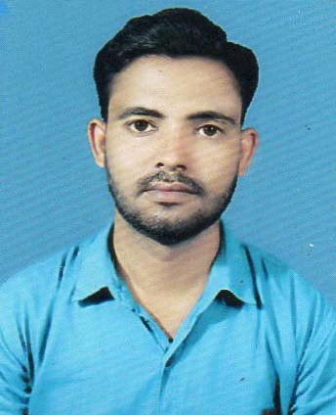
MD MEHRAM ALI ANSARI

Diploma in Arhitectural Cad
ITI with FITTER Trade
1 year apprenticeship in fitter trade
Contact No:- 8757775395,7667155815
Adhaar No:- 600923761639
Pan No:- AYXPA5381M
E-mail:- mdmehramali@gmail.com

PRESENT ADDRESS
Village+post- Hewai , Ps- Keredari , Dist- Hazaribagh, State- Jharkhand ,pin-825311

CAREER OBJECTIVE

 | Qualification |  |  | Board/University |  |  |  | Year |  | Percentage
 | 10 th |  |  |  | K.K.C HIGH SCHOOL |  |  | 2007 |  | 50 %
 | INTERMEDIATE [ I COM] |  |  |  | J.A.C (RANCHI) |  |  | 2009 |  | 45.5 %
 | ARCHITECTURAL CAD |  |  | C |  | VENTURE CAD CENTRE (RANCHI) |  | 2013 |  | 83%
 | ITI FITTER TRADE |  | NCVT (DELHI) |  |  |  |  | 2018 |  | 84%
 | EXPERIENCE LEARNING (TRAINING PROGRAM)
 |  |  | Company Name
1. Central coal field ltd .Birsa project urimari (sayal) 1 year work experience in fitter trade

2. Adani power plant jharkhand ltd (GODDA)1 year work experience in fitter trade

To work in a firm with a professional work driven environment where I can utilize and apply my knowledge, skills which would enable me as a fresh graduate to grow while fulfilling organizational goals.
BASIC ACADEMIC CREDENTIALS

IT PROFICIENCY

- Microsoft Office Word, Microsoft Office Excel, Microsoft Office Power Point
- Internet Browsing
- Auto Cad, Ravit , 3D Max

PROJECT
Fitters may work in the auto, aircraft, manufacturing, or mining industry where they are responsible for fitting, fabricating, and assembling the structural components that make up mechanical systems. They also repair and service machinery as required

INTERPERSONAL SKILL

- Humour mood behavior.
- Confident and Determined.
- Adaptability,Team spirit.
- Positive attitude.
- Soft Communication skill.
PERSONAL DETAILS
❖ | Father’s Name | - | MD AMANAT ALI ANSARI
❖ | Permanent Address | - | Village+post- Hewai , Ps- Keredari , Dist- Hazaribagh, Jharkhand pin-825311  20-04-1992
❖ | Date of Birth | -
❖ | Language Known | - | English & Hindi,Urdu
❖ | Marital Status | - | Married
❖   | Nationality/Religion  Interest & Hobbies | -  - | Indian / Muslim  Work at gym, playing cricket

DECLARATION

I do hereby declare that the above information is true to the best of my knowledge.

Date (Signature)

Place: md mehram ali ansari

